**Curriculum Vitae**

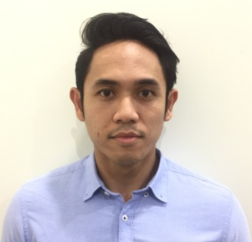

|  |  |
| --- | --- |
| **PERSONAL INFORMATION** | |
| Name | **Muhammad Faris Bin Mohd Ramlee** |
| Address | 59, Jalan USJ 2/5J,  Subang Jaya,  47600 Selangor. |
| NIRC | 880721-56-5537 |
| Age | 28 |
| Height | 170 cm |
| Weight | 70 kg |
| Nationality | Malaysian |
| Phone | 017-3284 202 |
| Email | muhammad.faris.ramlee@gmail.com |

|  |  |
| --- | --- |
| **EDUCATION BACKGROUND** | |
| 2006 - 2011  2012 - 2016 | **Multimedia University, Melaka**  Diploma in Telecommunication Engineering  CGPA: **2.92**  **Multimedia University, Cyberjaya**  Bachelor of Computer Science (Hons) with specialization in Software  Engineering  CGPA: **2.75** |
| 2001 - 2005 | **Sekolah Menengah Kebangsaan Seafield, USJ**  Sijil Pelajaran Malaysia 2005 (SPM) |

OBJECTIVE

Seeking a company to start career as an IT professional and will give all the commitment to result a satisfactory, reliable and quality performance and also to excel and achieve the level of an IT professional in the future.

|  |  |
| --- | --- |
| **CORE COMPETENCES** | |
| Language skills | Malay (Writing: 9, Speaking:9)  English (Writing: 8, Speaking: 7) |
| Computer skills | |  |  | | --- | --- | | **Software** | **Skills** | | C Programming | Average | | Microsoft Office  Adobe Photoshop  Adobe Illustrator  MySQL  PHP  Visual Basic  IBM DB2 | Good  Good  Average  Average  Beginner  Average  Average | |  |  | |
| Strength | **Fast learner, co-operative, dependable**, willing to work in team and **able to work under pressure.**  **Proficient communication** and leadership skills. Able to handle and solve problems efficiently.  **Discipline** and **self-motivated.** Dedicated and committed towards the task given. |

**JOB EXPERIENCES**

**1. Tenaga Nasional ICT**

Position Title : Intern

Duration : 3 Months

Job Responsibility :

* PDH (Transmission Technology) - Assist technician setting synchronization, troubleshoot and configure various PDH System
* Networking – Installation of 14 CAT-5 cables for SDH, upgrade PDH network (housekeeping) and preventive maintenance ICT equipments

**2. Media Prima Berhad**

Position Title : Data Entry

Duration : 6 Months

Job Responsibility :

* DB2 – Organize and input advertising data
* Infrastructure – PC Maintenances, Network, Database and Help Desk

**3. IX Telecom**

Position Title : Intern

Duration : 3 Months

Job Responsibility :

* Network Support – Assist network engineer in monitor, troubleshoot and configure network server of sub company
* Maintenance – Visit site to upgrade equipment, configure router and trace route station network path.

|  |  |
| --- | --- |
| **REFERENCES** | |
| **Dr. Kannan Ramakrishnan**  Senior Lecturer,  Faculty of Computing and Informatics,  Multimedia University,  Persiaran Multimedia,  63100 Cyberjaya, Selangor.  Email: kannan.ramakrishnan@mmu.edu.my | **Mr. Tong Hau Lee**  Deputy Chairman of Industrial Training Committee,  Multimedia University,  Persiaran Multimedia,  63100 Cyberjaya, Selangor.  Email: hltong@mmu.edu.my |